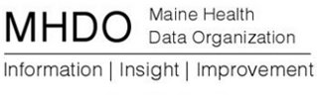

Super Data User Group

Monday, November 25, 2013

Muskie, Room 305

Portland, ME

1:00 p.m. to 2:00 p.m

Agenda

* Welcome/Introductions/Overview of Agency Transformation and End State Vision-15 minutes
* Current State of APCD/Future State of APCD-10 minutes
* Goals for Next 12 Months-5 minutes
* Data User Feedback-25 minutes
* Planning for Next Meeting-5 minutes

Conference call number: 877-455-0244

Conference code: 7281882859