CompareMaine

# Data Update Requirements

Title 22, Chapter 1683 section 8712 (2) Payments. The organization shall create a publicly accessible interactive website that presents reports related to payments for services rendered by health care facilities and practitioners to residents of the State. The services presented must include, but not be limited to, imaging, preventative health, radiology and surgical services and other services that are predominantly elective and may be provided to a large number of patients who do not have health insurance or are underinsured. The website must also be constructed to display prices paid by individual commercial health insurance companies, 3rd-party administrators and, unless prohibited by federal law, governmental payors. **Beginning October 1, 2012, price information posted on the website must be posted semiannually (every six months or 2x/year), must display the date of posting and, when posted, must be current to within 12 months of the date of submission of the information.**

## Update Schedule

|  |  |  |  |  |
| --- | --- | --- | --- | --- |
| Site Updated | Version | Cost Data Period | Quality Measures Updated[1] | Status |
| June 30, 2016 | 2.0 | 10/1/2014-9/30/2015 | HCAHPS Patient Experience Summary Star,  SIR for C. diff and MRSA | Complete |
| November 30, 2016 | 3.0 | 4/1/2015-3/31/2016[2] | HCAHPS Patient Experience Summary Star, Serious Complications (PSI90), SIR for C. diff and MRSA | Complete |
| August 31, 2017 | 4.0 | 10/1/2015-12/30/2016 | HCAHPS Patient Experience Summary Star, SIR for C. diff and MRSA | In progress |
| November 30, 2017 | 5.0 | 4/1/2016-3/31/2017 | HCAHPS Patient Experience Summary Star, PCMH / CG CAHPS Overall Provider Rating, Serious Complications (PSI90), SIR for C. diff and MRSA | Upcoming |
| June 29, 2018 | 6.0 | 10/1/2016-9/30/2017 | HCAHPS Patient Experience Summary Star, SIR for C. diff and MRSA | Upcoming |
| November 30, 2018 | 7.0 | 4/1/2017-3/31/2018 | HCAHPS Patient Experience Summary Star, Serious Complications (PSI90), SIR for C. diff and MRSA | Upcoming |

## **CompareMaine 4.0; August 31, 2017**

* Update HCAHPS Patient Experience Summary Star (7/1/15-6/30/16) and SIRs (7/1/15-6/30/16)
* Update cost data (10/1/15-12/30/16)
* Implement MAD
* Implement new facility review process
* Revise methodology for skin lesion removal procedures
* Regroup rural health facility locations together instead of separately
* Breakout professional and facility costs in current display

## **CompareMaine 5.0; November 30, 2017**

* Update PCMH/CG CAHPS Overall Provider Rating (2016-2017), HCAHPS Patient Experience Summary Star (10/1/15-9/30/16), Serious Complications (7/1/14-6/30/16), and SIRs (10/1/15-9/30/16)
* Update cost data (4/1/2016-3/31/17)
* Detailed display for researchers
* Explore adding a feature to filter results in the data display by facility type
* Revised quality data display with new measures **at the procedure level**
* Cost data trend comparison

# **Details on CompareMaine 4.0 Enhancements**

## Implement Median Absolute Deviation (MAD) Process

The Median Absolute Deviation (MAD) Process automatically identifies outliers on CompareMaine and flags them for further investigation. The MAD is used to investigate how widely data points deviate from the median. The process will indicate how much a facility’s cost estimate for a healthcare procedure deviates from the statewide median for that procedure.

The MAD will identify combinations of facilities, payers and procedures that are higher or lower than the established thresholds for deviation from the statewide median for that procedure. Given that health care costs have natural variation, this procedure will be used to identify extreme outliers that are artifacts of the APCD data. Once outliers have been identified, we will drill down internally to determine the potential cause for the result. The facility and/or payer will also be contacted if its median is above or below the statewide median by a pre-determined amount (*to be determined w/ MHDO*).

## Revised Methodology for Skin Lesion Removal

In previous versions of CompareMaine, skin lesion estimates for CPT codes 17000 and 17110 were calculated using the 3M’s Medical Episode Grouper, a tool that creates episodes of care by analyzing claims data to identify diagnoses. The MEG created some high cost episodes for these codes that involved some intensive services such as cancer treatments. We felt these episodes were not representative of the code and removed both procedures from the site. We are currently investigating the best way to calculate estimates for these procedures on CompareMaine.

## Regroup Rural Facilities

During the QC of CompareMaine 2.0, the following organizations requested that we regroup their facilities. Previously, each location of the network was displayed separately. In CompareMaine 4.0, the locations will be grouped together into their respective networks. This has following potential impacts: an increase in the number of facilities reporting data in the network, and increase in the number of procedures displayed on CompareMaine for that network, and an increase in the number of claims per procedure. Italics indicate facilities not previously included on CompareMaine due to low N issues.

* Community Clinical Services
  + B Street Health Center
  + CCS Family Health Center
  + *CCS Psychiatry at Central Maine Family Practice*
  + Second Street Health Center
* Penobscot Community Health Care
  + Brewer Medical Center
  + *Capehart Community Clinic*
  + Helen Hunt Health Center
  + *Jackman Community Health Center*
  + *Pediatrics*
  + Penobscot Community Health Center
  + Seaport Community Health Center
  + Specialty Clinic
  + *Summer St. Community Clinic*
  + Winterport Community Health Center
* Pines Health Services
  + *Kimball Community Health Center*
  + Pines Caribou Health Center
  + Presque Isle Health Center
  + St. John Valley Health Center
  + *Washburn Health Center*
  + Women and Children’s Center
* Portland Community Health Center
  + Portland Community Health Center (PCHC)
  + *PCHC at Brickhill*
  + *PCHC at Franklin Towers*
  + *PCHC at Preble St.*
  + *PCHC at Riverton Park*
* HOMETOWN Health Center (Formerly Sebasticook Family Doctors)
  + *Canaan*
  + *Dexter*
  + *Dover-Foxcroft*
  + Newport
  + *Pittsfield*

## Breakout of Professional and Facility Costs

Average Total Cost will be broken out by professional and facility costs. The following mock-up conveys the general concept:

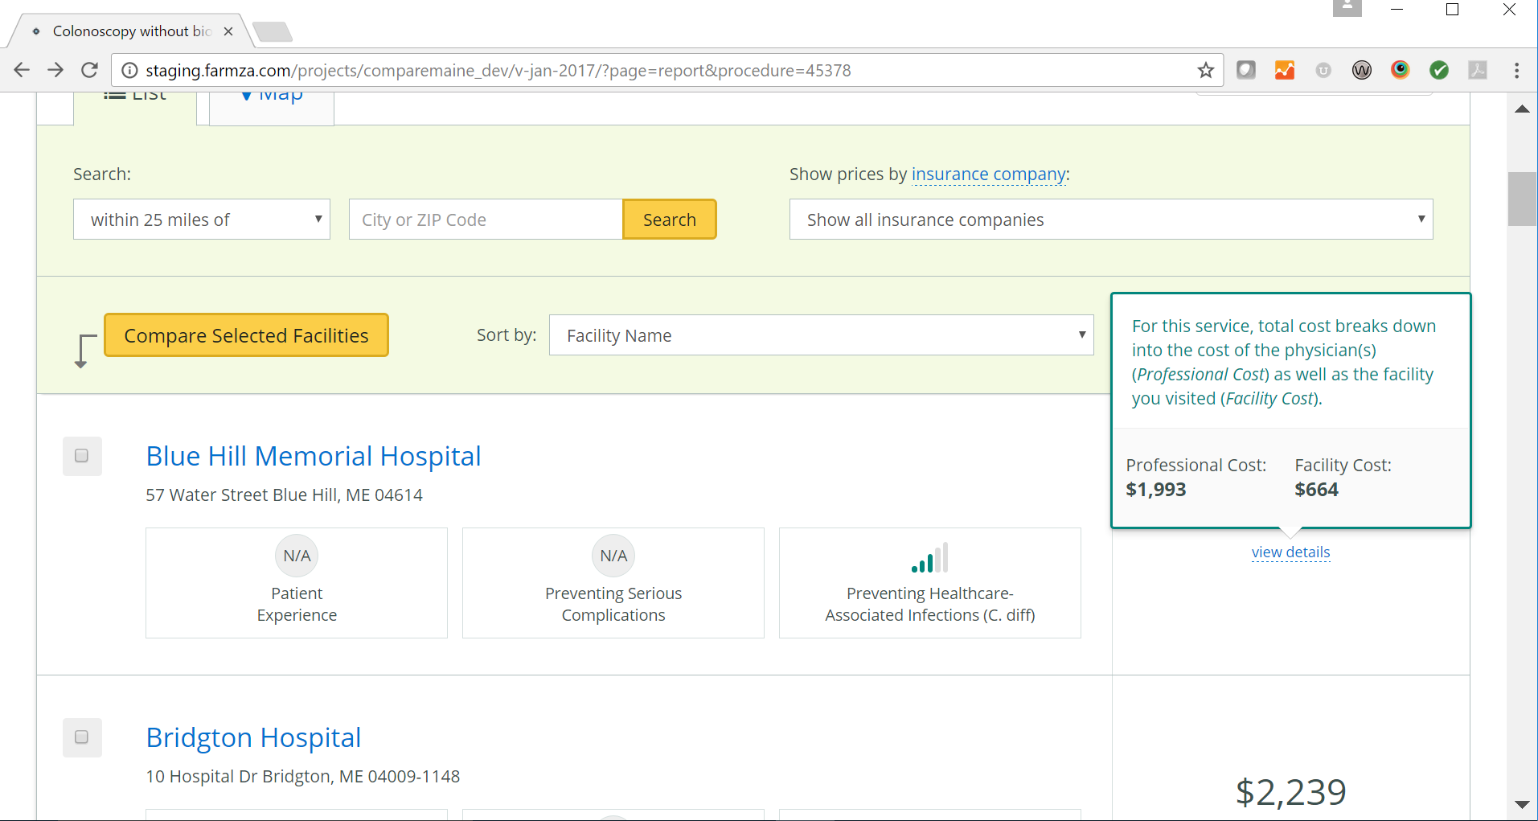

* **Roll-over Text for Average Total Cost:** The average amount paid for a healthcare procedure, calculated using the median. The median is the middle number in a range of numbers from lowest to highest. This cost includes payments from an insurance company, as well as co-pays, co-insurance or deductibles from the patient.
* **Replace the “View details” Roll-over Under the Average Total Cost in the Image Above with “Cost Breakdown”:** The average total cost is broken out into costs paid to the healthcare facility and professional(s) providing services.
  + **Facility Cost: $XYZ**paid to the organization providing healthcare services and procedures.
  + **Professional Cost: $XYZ** paid to the healthcare providers, such as nurses, doctors or therapists, for providing healthcare services and procedures.
* **Dictionary Definition for Professional** (Same as Ad Hoc Consumers)**:** An individual healthcare provider, such as a nurse, doctor or therapist, who provides direct services or procedures to a patient.
* **Dictionary Definition for Facility:** An organization that provides healthcare services and procedures. This includes hospitals, surgical centers, diagnostic imaging centers, health centers, laboratories, and clinics.

1. **HCAHPS Patient Experience Summary Star** will be updated annually in June - the data currently on CompareMaine are from 7/1/2014-6/30/2015, data are downloaded from CMS Hospital Compare, [https://www.medicare.gov/hospitalcompare/Data/Data-Updated.html#](https://www.medicare.gov/hospitalcompare/Data/Data-Updated.html).

   **PCMH/CG CAHPS Overall Provider Rating** will be updated every two years in November - the data currently on CompareMaine are from 2014 and 2015, data are downloaded from Patient Experience Matters <http://www.mainepatientexperiencematters.org/about-the-data.php>; CAHPS Database (Westat).

   **Serious Complications** will be updated annually in November - the data currently on CompareMaine are from 7/1/2013-6/30/2015, data are downloaded from CMS Hospital Compare, [https://www.medicare.gov/hospitalcompare/Data/Data-Updated.html#](https://www.medicare.gov/hospitalcompare/Data/Data-Updated.html).

   **SIRs for C. diff and MRSA** will be updated every June and November - the data currently on CompareMaine are from 10/1/2014-9/30/2015, data are downloaded from CMS Hospital Compare, [https://www.medicare.gov/hospitalcompare/Data/Data-Updated.html#](https://www.medicare.gov/hospitalcompare/Data/Data-Updated.html)
2. The data update originally scheduled for November 30, 2016 will not take place due to the impact of the *Gobeille vs. Liberty Mutual*.